Health Eligibility Case Management System (HECMS)
Developer’s Guide

Enrollment System Redesign (ESR)

Version 1.1
September 2011
Department of Veterans Affairs
Product Development
Management, Enrollment and Financial Systems (MEFS)
Revision History
Date | Version | Description | Project Manager | Author
9/13/2011 | 1.1 | Updated cover and footer dates to correspond with new National Release date for 3.5 to September 2011. | Jennifer Freese | Tom Hamilton
7/18/2011 | 1.0 | Initiated document version to replace application version on cover. Updated Release Dates to August 2011. | Jennifer Freese | Tom Hamilton
7/08/2011 |  | Updated Release Dates to July 2011. Updated Related Documentation section. Updated Office of Enterprise Development to Product Development on title page. | Jennifer Freese | Janet Darmanin
3/31/2011 |  | Updated all Release Dates to March 2011. Updated Related Documentation section and links. | Jennifer Freese | Tom Hamilton
9/16/2010 |  | Updated styles and general edits for version 3.3. | Jennifer Freese | Janet Darmanin
4/20/2010 |  | Updated 3.0 document with the most current 3.0 information in preparation for uploading to VDL. Updated footers to March 2009 to match ESR 3.0 Release Date. | Brian Morgan | Tom Hamilton
8/11/09 |  | Changed HealtheVet cover graphic back to VA Seal per Brian Morgan. | Sookie Spence | Tom Hamilton
7/6/09 – 7/7/09 |  | Changed cover graphic from VA Seal to HealtheVet logo. Updated cover and footer dates. Internal links removed as required by FOIA. Updated 3.0 to 3.0.1. | Sookie Spence | Tom Hamilton
3/10/09 |  | Added links to PSIM and Common Services to Related Documentation Section. | Gerry Lowe | Cory Spielvogle
3/10/09 |  | Added link to Troubleshooting Section. | Gerry Lowe | Cory Spielvogle
3/09/09 |  | Added list of Tools and Utilities based on developer input. | Gerry Lowe | Cory Spielvogle
2/23/09 |  | Minor change to reference of HEC Legacy System within introduction. | Gerry Lowe | Cory Spielvogle
10/8/08 |  | Minor updates based on 10/7 Final Review call. Updated Related Documentation list. | Gerry Lowe | Tom Hamilton
9/26/08 |  | Added developer (CR) updates. | Gerry Lowe | Tom Hamilton
9/16/08 |  | Added ESR 3.0 HECMS application hyperlink. Added other minor updates. | Gerry Lowe | Tom Hamilton
9/15/08 |  | Minor updates to Acronyms and Descriptions. | Gerry Lowe | Tom Hamilton
8/28/08 |  | Inserting EVC R2 info from DG 688 PD. | Gerry Lowe | Tom Hamilton
8/27/08 |  | Updates based on developer input. | Gerry Lowe | Tom Hamilton
8/15/08-8/18/08 |  | Create Initial draft Developer’s document. | Gerry Lowe | Tom Hamilton

Table of Contents
Health Eligibility Case Management System (HECMS) V3.5 1
Orientation 1
Introduction 1
Purpose 5
Scope 5
Acronyms and Descriptions 6
Target Audience 7
Related Documentation 7
Public Interfaces 7
Exposed HealtheVet Interfaces 7
Demographics Services 7
Person Services 8
Component Details 9
EntityKey 9
VPIDEntityKey 9
EntityKeyFactory 9
EligibilitySummary 9
DemographicsChangeSummary 9
DemographicsChangeEvent 10
DemographicsChangeType 11
Client Side Integration 11
Package Structure 12
Configuration Information 13
Configuration 13
Configuration Files 13
Jar files 13
NDS Configuration 13
Database Configuration 13
Developer Workstation Setup 13
Installing the Client 13
Tools and Utilities 14
Troubleshooting 14
Javadocs 14

Health Eligibility Case Management System (HECMS) V3.5

Orientation
N/A

Introduction
HECMS V3.5 is the HealtheVet replacement system for the product known as HEC Legacy. It is both a re-host of HEC Legacy and in some instances (use cases/features), a re-engineering. HECMS allows staff at the HEC to work more efficiently and determine patient eligibility in a more timely manner. Messaging with the VAMC allows updates to the enterprise enrollment system to be shared with the field.
It is one component of the "system of systems" needed to implement the HealtheVet REE (Registration, Eligibility and Enrollment) environment.
The Enrollment VistA Changes (EVC) Release 2 project was undertaken to support technology and business changes that were occurring with the implementation of the HECMS V3.0 project. Some modified and new business functionality is being included in the new system, and corresponding changes are necessary in VistA for preliminary determination of the veteran's Enrollment and Eligibility status. The EVC R2 project was released just prior to the HECMS V3.0 project.
New features of the EVC R2 project are as follows:
- Enhance Data Sharing between VistA and HECMS
The following fields will be added to the HL7 Z07 message builder:
- Temporary Address Province
- Temporary Address Postal Code
- Temporary Address Country
- Spouse Inactivation Date
- Dependent Inactivation Date
- Agency/Allied Country
The following fields will be added to the HL7 Z11 message receiver:
- POW From Date
- POW To Date
- POW Location
- P&T Effective Date
- Agency/Allied Country
The following fields will be added to the HL7 Z05 message receiver:
- Province
- Postal Code
- Country
- Bad Address Indicator
- Email Address
- Email Address Change Date/Time
- Email Address Change Site
- Email Address Change Source
- Cellular Number
- Cellular Number Change Date/Time
- Cellular Number Change Site
- Cellular Number Change Source
- Pager Number
- Pager Number Change Date/Time
- Pager Number Change Site
- Pager Number Change Source
- Street Address Line 3
The following fields will be added to the HL7 Z10 message receiver:
- SSN Verification Status (spouse/dependent)
- Spouse Inactivation Date
- Dependent Inactivation Date
- Changes to Agent Orange Exposure Processing
The Agent Orange Exposure Location field (#.3213) in the Patient file (#2) is being modified. A new Exposure Location of OTHER is being added.
A change is being made to the Enrollment priority algorithm. Only veterans with an Agent Orange Exposure Location of Vietnam will be eligible for priority group 6.
- Add Permanent and Totally (P&T) Disabled Effective Date
A new field, P&T Effective Date (#.3013), will be added to the Patient file (#2). This field will be edited and displayed on Screen 7 of Registration next to the P&T indicator field.
Once the patient's eligibility has been verified by HEC, the P&T indicator and the P&T Effective Date will no longer be editable.
- Receive POW Information from HEC
POW From and To Dates, and POW Location will be sent from HEC. Once the patient's eligibility record is verified by HEC, POW data will no longer be editable.
- Locking of SSN Once Verified
A new field, SSN Verification Status (#.0907), will be added to the Patient file (#.02). A new field, SSN Verification Status (#.11), will be added to the Income Person file (#408.13).
Once the SSN Verification Status has been given a status of Verified, the SSN for the patient, spouse, or dependent can no longer be edited.
- Address Sharing Functionality
Support for foreign addresses in patient Permanent, Temporary and Confidential address will be added.
New fields will be added to the Patient File (#2). They are:
- Province (#.1171)
- Postal Code (#.1172)
- Country (#.1173)
- Temporary Address Province (#.1221)
- Temporary Address Postal Code (#.1222)
- Temporary Address Country (#.1223)
- Confidential Addr Province (#.14114)
- Confidential Addr Postal Code (#.14115)
- Confidential Addr Country (#.14116)
Consistency checks have been modified to check for patient's permanent address country.
Registration, Enrollment and Patient Inquiry Screens have been modified to prompt and/or display country, postal code and province for foreign countries. For United States, the country field has been added. The other address fields are unchanged.
The following functionality has been modified to support foreign address:
- Report - All Address Changes [DG All Address Change Report]
- Report - All Address Change with Rx [DG All Address Change with RX]
- View Patient Address [EAS VIEW PATIENT ADDRESS]
- Zero Day Letters Print [EAS MT 0 DAY LETTER PRINT]
- Thirty Day Letters Print [EAS MT 30 DAY LETTER PRINT]
- Sixty Day Letters Print [EAS MT 60 DAY LETTER PRINT]
- IVM Address Change Log Report [IVM ADDRESS CHANGE LOG REPORT]
The API ADD^VADPT has been modified.
The new nodes for the address array (VAPA()) are as follows.
- VAPA(23) - permanent or temporary Province (if temp address is current and active, it's temp)
- VAPA(24) - permanent or temporary Postal Code (if temp address is current and active, it's temp)
- VAPA(25) - permanent or temporary Country (if temp address is current and active, it's temp)
- VAPA(26) - confidential Province
- VAPA(27) - confidential Postal Code
- VAPA(28) - confidential Country
Addresses will not be converted, but a country will be required when the patient permanent, temporary, or confidential address is edited.
- Share Inactivation Date for Spouse and Dependent
Prior to EVC release 2, inactive dependents that were not on a current means test, were not shared. With EVC R2, inactive dependents will be shared even if they are not on a current means test.
- Share Non-Veteran Information
The Agency/Allied Country field for Patient Types Allied Veteran and Non-Veteran Other will be shared with the HEC. Additionally, VistA will no longer change the service connection value when uploading from the HEC.
- Modify Means Test Data Collection
Means Test data collection in VistA will be aligned with the February 2005 1010EZ form.
A means test version indicator will be created and support the display and collection of Means Test information for both the 1010EZ form prior to Feb. 2005 and the 1010EZ form from Feb. 2005. The changes outlined for this patch regard those that support the Feb 2005 form. Means Test information collected prior to installation of this patch will continue to be collected, printed, and displayed in the pre-Feb. 2005 format.
The Means Test Version indicator will be evaluated in the following VistA options:
- Load/Edit Patient [DG LOAD PATIENT DATA]
- Register a Patient [DG REGISTER PATIENT]
- Add a New Means Test [DG MEANS TEST ADD]
- Complete a Required Means Test [DG MEANS TEST COMPLETE]
- Edit an Existing Means Test [DG MEANS TEST EDIT]
- View a Past Means Test [DG MEANS TEST VIEW TEST]
- Purge Duplicate Income Tests [DG CLEANUP INCOME TEST DUPES]
- Add a Copay Exemption Test [DG CO PAY TEST ADD]
- Edit an Existing Copay Exemption Test [DG CO PAY TEST EDIT]
- View a Past Copay Test [DG CO PAY TEST VIEW TEST]
Income Available Response collected for Dependent Child(ren) will now support collection of children Net Worth Dollar Amounts (for Feb. 2005 form). Children Net Worth Dollar amounts will be collected with the new form.
A limit of 19 dependent children will be collected for a Means test. This limit applies to those dependents with relationships of son, daughter, step-son, and step-daughter.
The collection of Previous Calendar Year Gross Annual Income with Feb 2005 Data Format will be changed to collect 3 data elements rather than the 10 data elements collected with the pre-Feb. 2005 format.
Means Test data collection will collect the Gross Medical Expenses dollar amount, within Deductible Expenses, labeled as "Total Non-Reimbursed Medical Expenses".
February 2005 1010EZ form Means Test data collection will no longer require a spouse or dependent child (associated with the Means Test) to collect Funeral and Burial expenses.
The collection of Previous Calendar Year Net Worth with Feb 2005 Data Format will be changed to collect 3 data elements rather than the 5 data elements collected with the pre-Feb. 2005 format.
The system will continue to display the summary Income, Net Worth, and Deductible Expenses amounts in the Feb 2005 Data Collection Format as was displayed with the pre-Feb 2005 data collection format. The system will continue to calculate the summary Income, Net Worth, and Deductible Expense amounts in the Feb 2005 Data Collection Format with the same formulas as with the Existing Data Collection format.
Entry of means test information in the Feb 2005 Data Collection format will produce the same means test status that results when the means test information is entered with the Existing Data Collection format.
The "Copy Data" function will be removed from the Means Test user interface for both Feb 2005 form and pre-Feb 2005 form. The "Copy Data" function will still be performed by the Means Test system when done automatically. For example, if the Primary Eligibility Code changes from Non-Service Connected to Service Connected, a Pharmacy Copay test will automatically be created. When this "automatic" copy occurs, the Annual Income information will be checked for the data collection form. If that data is in pre-Feb 2005 form, it will convert to the Feb 2005 form to match the newly created Pharmacy Copay Test.
More information can be found at the project’s VistA Documentation Library (VDL) web site and the Technical Services Project Repository (TSPR) project notebook web site. They are as follows:
VDL: http://www.va.gov/vdl/application.asp?appid=183
TSPR: http://10.4.237.3/warboard/anotebk.asp?proj=884&Type=Active (this is an internal link accessible only on the VA network)
The HECMS application is located at the following URL:
HECMS v3.5: https://vaww.esr.aac.va.gov/esr/ (this is an internal link accessible only on the VA network)

Purpose
This document provides information for Java developers to integrating their code with Enrollment System Redesign (ESR) synchronous interfaces. These application program interfaces (API) use Java 2 Enterprise Edition (J2EE) Enterprise Java Beans (EJB) and are currently designed to work with a J2EE 1.3 compliant application server.

Scope
This document is describes the APIs included in the ESR Internal Release R3/R4.

Acronyms and Descriptions
Acronym | Description
ADR | Administrative Data Repository
API | Application Program Interface
CAIP | Cross-Application Integration Protocol
DOD | Date of Death
DS | Delivery Service
EE | Eligibility and Enrollment
EJB | Enterprise Java Bean
ESR | Enrollment System Redesign
EVC | Enrollment VistA Changes
HEC | Health Eligibility Center
HECMS | Health Eligibility Case Management System
HL7 | Health Level Seven
JAR | Java ARchive
JDBC | Java Database Connectivity
J2EE | Java 2 Enterprise Edition
NDS | Naming Directory Services
P&T | Permanent & Total
POW | Prisoner of War
PS | Person Service
PSD | Person Service Demographics
PSIM | Person Service Identity Management
SDS | Standard Data Service
SSA | Social Security Administration
SSN | Social Security Number
TSPR | Technical Services Data Repository
VistA | Veterans Health Information Systems and Technology Architecture
VDL | VistA Documentation Library
VPID | Veterans Affairs Person Identifier

Target Audience
The target audience for this document is HealtheVet application developers needing to access the ESR external APIs.

Related Documentation
- 3.5 (HECMS) Security Guide (http://www.va.gov/vdl/application.asp?appid=183)
- 3.5 (HECMS) Installation Guide (http://www.va.gov/vdl/application.asp?appid=183)
- 3.5 (HECMS) Systems Management Guide (http://www.va.gov/vdl/application.asp?appid=183)
- 3.5 (HECMS) User Manual (http://www.va.gov/vdl/application.asp?appid=183)
- 3.5 (HECMS) Release Notes (http://www.va.gov/vdl/application.asp?appid=183)
- ESR 3 0 Deployment - Phase 2 - Software Sequencing Plan (SSP)
- ESR 3.0 Operations Guide – Operations Guide (this is an internal link accessible only on the VA network)
- PSIM Operations Guide – Operations Guide
*Person Service Identity Management (PSIM) documentation can be found on the Technical Services Project Repository (TSPR) project notebook page by clicking here.
*Links to other Common Services used in the HECMS application can be found at the CS - ADR - ESR Integrated Project Home SharePoint site by clicking here (username and password required).

Public Interfaces

Exposed HealtheVet Interfaces
The APIs that can be accessed by other HealtheVet applications are documented here. They are grouped into the below services and registered in NDS with these groupings.

Demographics Services
Notify ESR of an ADR Demographics Update - This is critical such that ESR can interject its business processing. This includes 1) potentially recalculating the enrollment status, 2) sending the appropriate communication letters, and 3) transmitting the appropriate HL7 messages to applicable VistA sites.
public void notifyOfDemographicsChange( DemographicsChangeSummary demographicsChangeSummary ) throws ESRException;
In order to create a DemographicsChangeSummary, the following attributes are required.
- VPIDEntityKey
- At least one DemographicChangeEvent
Here is an example of a client invocation:
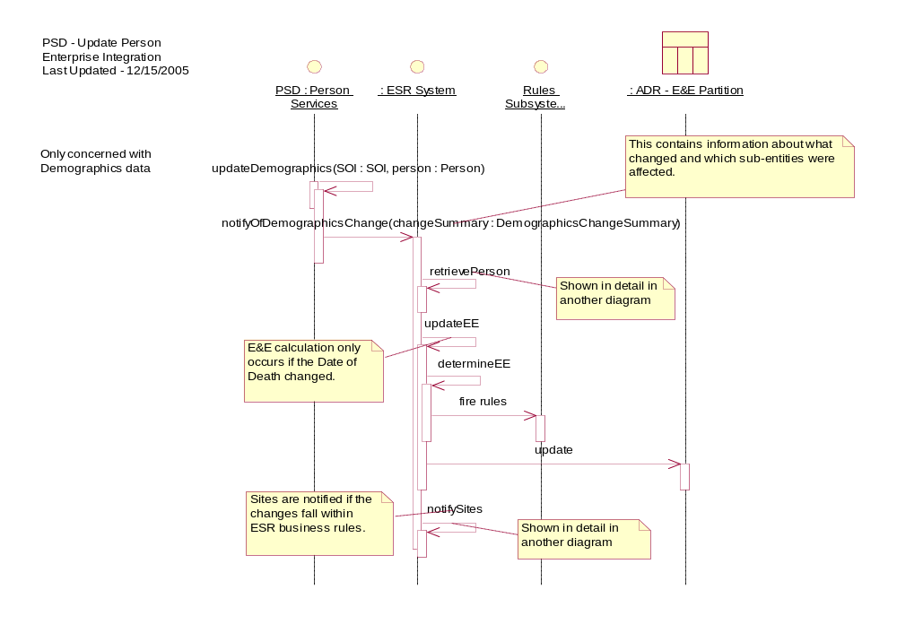

Person Services
VPID Link – This API is essentially a notification to ESR that a link event has occurred at the identity level. In lieu of a decision for IP5 to use Delivery Services, this API will serve as the synchronous integration point for enrollment data.
public void link( VPIDEntityKey deprecatedVPID, VPIDEntityKey survivingVPID ) throws ESRException;
VPID Move – This API is essentially a notification to ESR that a move event has occurred at the identity level. In lieu of a decision for IP5 to use Delivery Services, this API will serve as the synchronous integration point for enrollment data.
public void move( String dfn, String stationNumber, VPIDEntityKey fromVPID, VPIDEntityKey toVPID) throws ESRException;
Eligibility Summary – This API allows the HealtheVet enterprise to synchronously retrieve the Eligibility and Enrollment Summary for a Person via their VPID. Current data returned has been largely driven by HealtheVet requirements of clients.
public EligibilitySummary getEligibilitySummary(VPIDEntityKey VPID) throws ESRException;

Component Details
In order to send information to an API, or receive information from an API, a set of classes has been defined to compliment the Java provided classes. These Java Value Object classes are serializable across the network.

EntityKey
Interface representing an entity’s identifier.

VPIDEntityKey
Interface representing an enumerated Person’s VPID.

EntityKeyFactory
Factory component to create an EntityKey instance for various business objects.

EligibilitySummary
This pojo aggregates Eligibility and Enrollment (EE) data regarding a Person. This data set can be grouped in the following groupings.
- EE data (Primary Eligibility Code, etc.)
- Military Service data (POW Status Indicated, Service Branch, Period of Service, etc.)
- Financial data (Legal dependents name on income statements, etc.)
- Death data (DOD source of notification, etc.)

DemographicsChangeSummary
A DemographicsChangeSummary aggregates information regarding focused changes to the demographic data of an enumerated Person. It provides support for multiple updates to the same Person, encapsulated within each DemographicsChangeEvent object.
The class diagram is as follows:
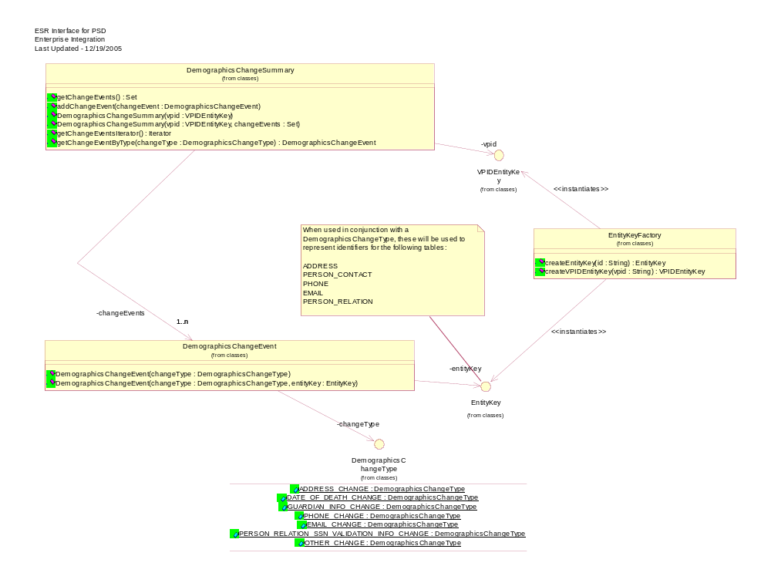
vpid – Strongly typed object representing the identifier for the enumerated Person.
changeEvents – Contains the multiple change events.

DemographicsChangeEvent
Encapsulates a specific demographics change event. This includes the type of change, and an optional identifier representing the specific object that was changed.
The class diagram is as follows:
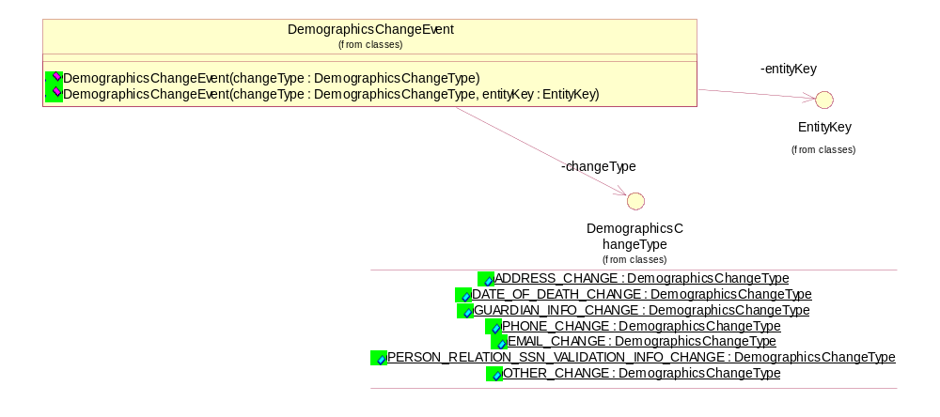
entityKey – Strongly typed object representing the identifier for the specific object that changed (e.g., Permanent Address Id).
changeType – Strongly typed object representing the finite set of classifications (from which ESR is concerned) of change types.

DemographicsChangeType
Represents the finite set of classifications of change types from which ESR is concerned. Because ESR business rules are different depending on what actually changed, it is paramount that the details of the change be articulated.
ADDRESS_CHANGE – Any change to an Address. Since there can be multiple Addresses for an enumerated Person, the associated EntityKey for the record in ADR.ADDRESS is required.
DATE_OF_DEATH_CHANGE – Any change to the data of death, including blanking it out.
DATE_OF_DEATH_ADD – Special case of change of Date of Death for cases when there was no previous Date of Death and a non-null value has been provided.
GUARDIAN_INFO_CHANGE - Any change to Guardian Info. Since there can be multiple Guardians for an enumerated Person, the associated EntityKey for the record in ADR.PERSON_CONTACT is required.
PHONE_CHANGE - Any change to a Phone number. Since there can be multiple Phone numbers for an enumerated Person, the associated EntityKey for the record in ADR.PHONE is required.
EMAIL_CHANGE - Any change to an Email address. Since there can be multiple Email addresses for an enumerated Person, the associated EntityKey for the record in ADR.EMAIL is required.
PERSON_RELATION_SSN_VALIDATION_INFO_CHANGE - Any change to the SSN Validation Info for a Person Relation (only ones currently supported are Dependent and Spouse). Since there can be multiple Person Relations for an enumerated Person, the associated EntityKey for the record in ADR.PERSON_RELATION is required.
OTHER_CHANGE - Any other non-specified change to the demographics information for an enumerated Person.

Client Side Integration
All PS APIs are Cross-Application Integration Protocol (CAIP) compliant. Since the APIs are CAIP compliant, all of the APIs can be accessed using the same logic. ESR exposes two CAIP Business Delegates, one for Demographics and one for general Person services. The logic to illustrate calling an API is in the following diagram:
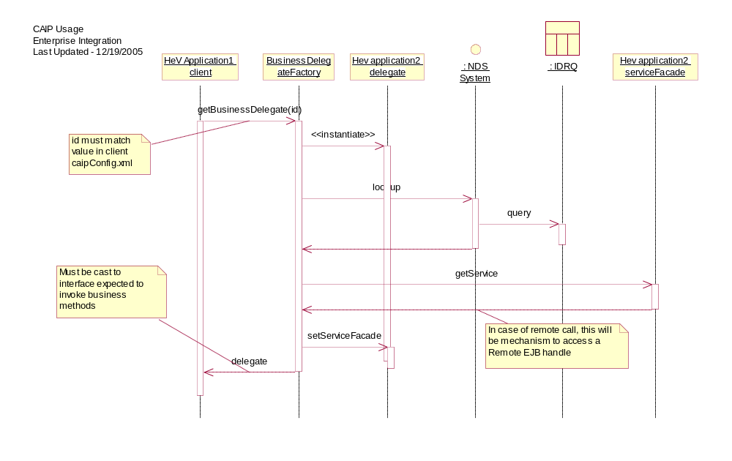
Once the delegate is retrieved from the BusinessDelegateFactory, it is the responsibility of the application to create any Java Value Objects that need to be passed in to an API.
This sequence diagram can be illustrated in one Java source code line (for example):
DemographicsServicedelegate = (DemographicsService) BusinessDelegateFactory.getBusinessDelegate("ESRDemographicsService");

Package Structure
The Java package structure and the class location are indicated in the following table.
Package | Classes
gov.va.med.esr.service.external.demographics | Demographics*
gov.va.med.esr.service.external.person | PersonService*
 | VPIDEntityKey
 | VPIDEntityKeyImpl
 | EntityKey
 | EntityKeyImpl
 | EntityKeyFactory
 | EligibilitySummary

Configuration Information

Configuration

Configuration Files
Several configuration files are included with the release. These files are included in the ESRClientZip.zip, and include the following:
- ESRClientConfig.jar– a jar file containing the client CAIP configuration information. This information can be incorporated into a user defined configuration file. Keep in mind to update the proper NDS server for your usage server.

Jar files
There are several jar files included with this release. You can find current version numbers in the subsequent Manifest.mf files contained within each jar. These files are included in the ESRClientZip.zip, and include the following:
- CAIP – CommonServices CAIP components
- NamingDirectoryService-client – CommonServices NDS components
- ESRClient – the ESR Client software.
- A listing of non-VA related third party dependent jars can be found in the readme.txt.

NDS Configuration
The NDS maintenance application will need to be configured in order for the delegate to find the service façade. See the NDS documentation for details.

Database Configuration
Database configuration is not needed on the client side.

Developer Workstation Setup

Installing the Client
This section will document how to extract and install the client portion of ESR.
The ESR Client software is delivered as a ZIP file that contains all of the JAR files and configuration files needed for execution. The following steps can be used to extract and install these files in a development environment.
- Obtain the ESRClient zip file.
- Extract the ESRClient zip file to a directory on your hard drive.
- Copy the jar files included to the proper location so that they are placed in the classpath of your application.
- Copy or merge the caipConfig.xml file to a location where it can be found on your classpath. If you already have a caipConfig.xml file, merge the information from the ESRClient caipConfig.xml file in to your existing file.
There is a supplied JUnit test that can be used to test the setup. Execute the class gov.va.med.esr.service.external.TestCAIPClientToESR to execute the tests. Be sure to include the jars from the zip (including third party jars) in the client classpath.

Tools and Utilities
- TOAD
- BMC Patrol
- Introscope
- Eclipse (Java IDE)
- WebLogic 8.1 (Application Server)

Troubleshooting
For ESR troubleshooting information, click here. This is a living document and will be updated periodically.

Javadocs
N/A

